  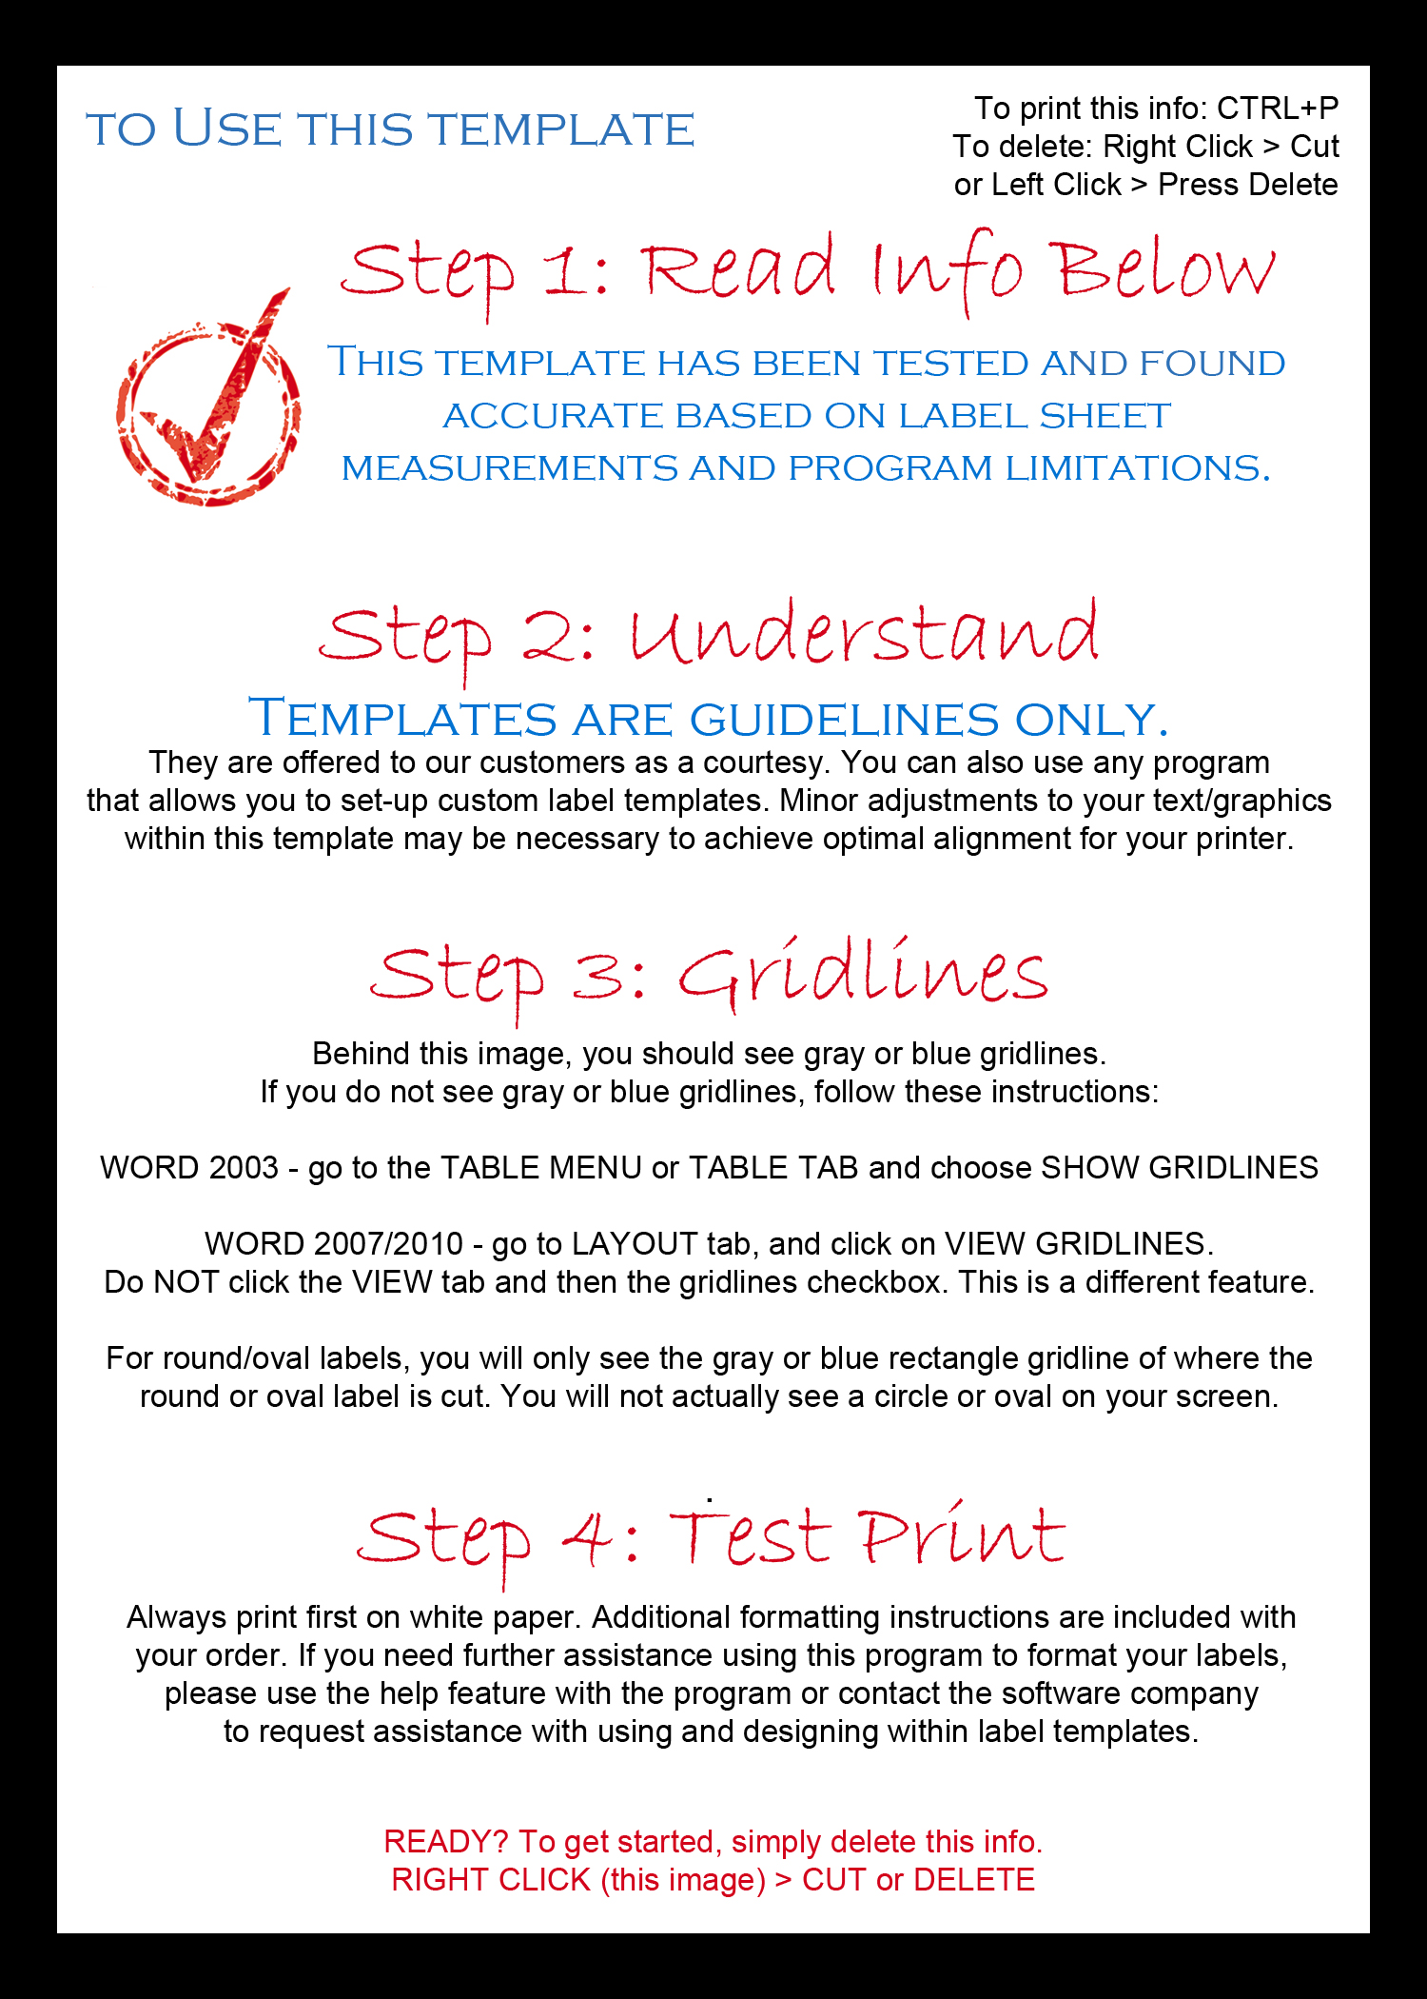 |  | -The image has been left in tag cell #1 to help you understand the printable area, you can delete it along with this note when you are ready
Templates are guidelines only and some adjustment should be expected to print properly on your printer. Always print on white paper first before printing on your labels or tags.

