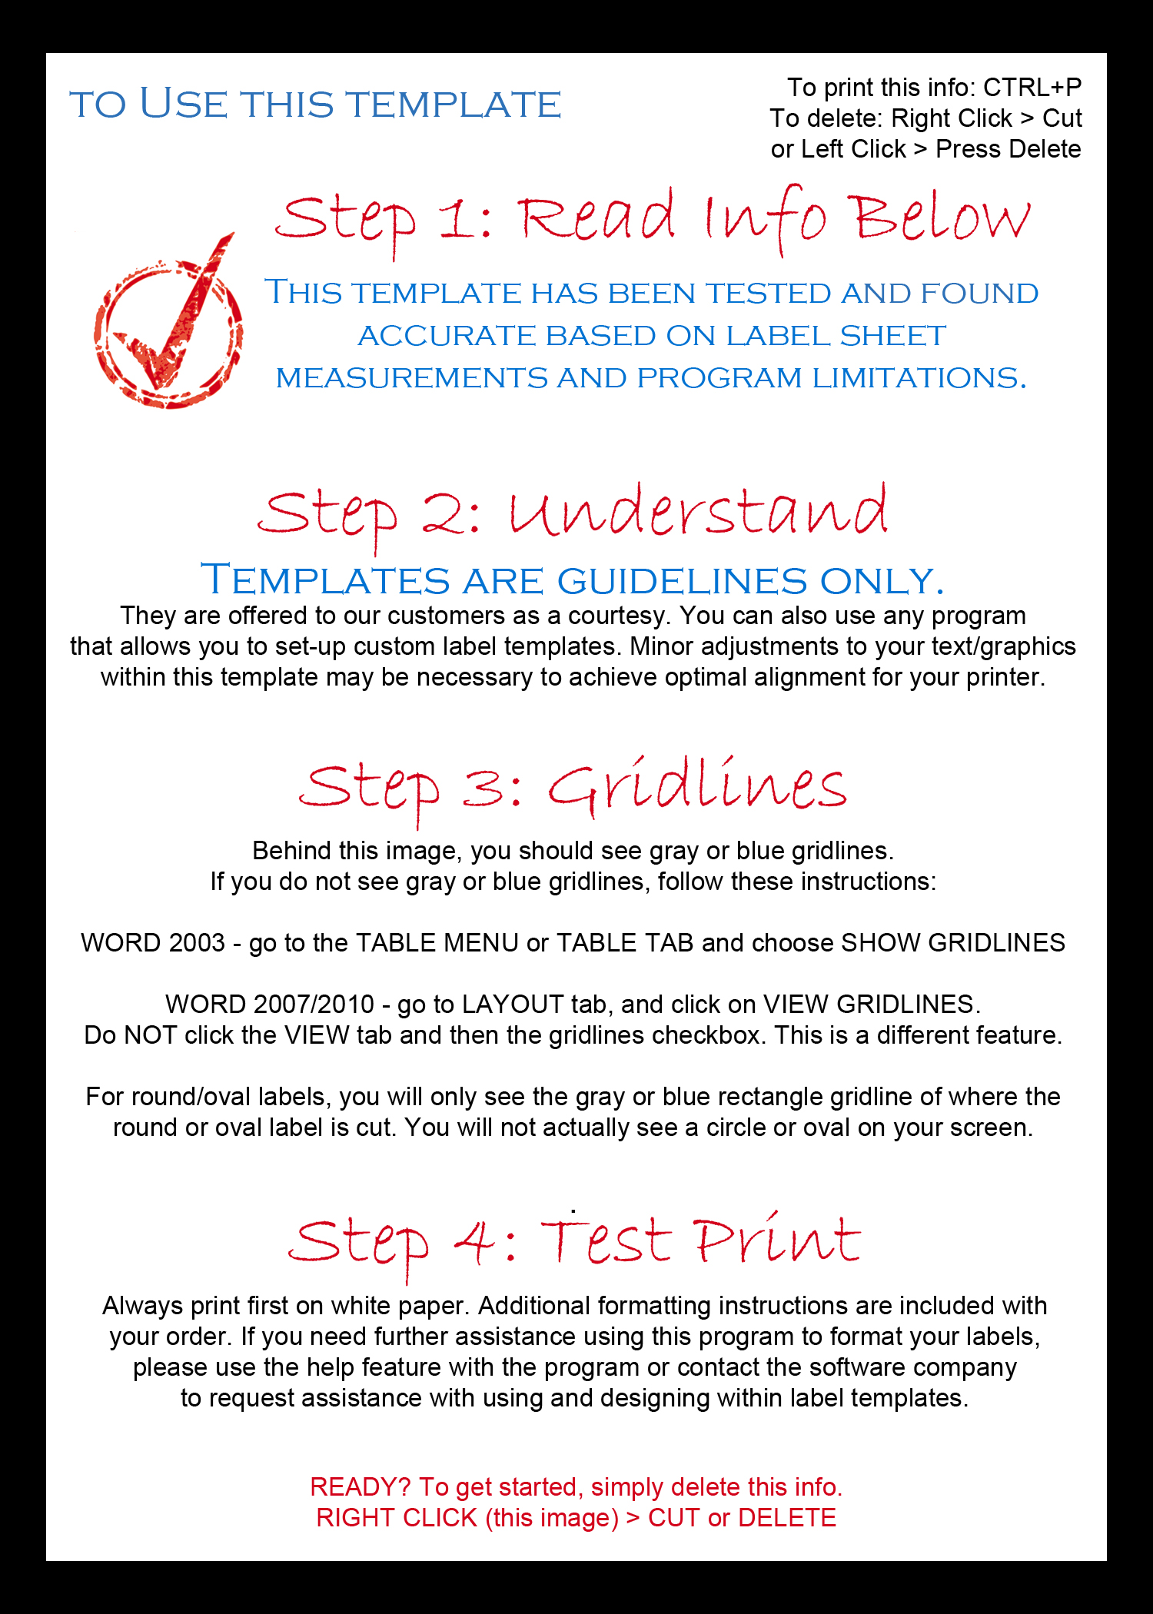
On this sheet, the X marks the bottom of the sheet – the gripper marks the top of the sheet.

